There are so many beautiful “π” arts everywhere, and I wanted to practice ggplot2 by mimicing those arts [further more](https://chichacha.netlify.com/2018/10/13/visual-art-with-pi-using-ggplot2-circlize/). Another pi art caught my eye is random walk of pi digits. Here’s one of examples in [WIRED magazine](https://www.wired.com/2012/06/a-random-walk-with-pi/).

For random walk to work, I’ve assigned direction to “walk” depending on digits 0-9.

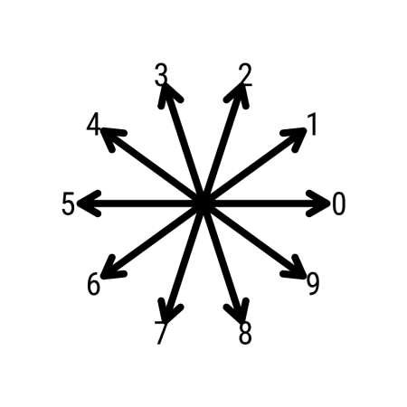

I’ve prepared data frame as below, so I can use ggplot2 to plot

## pi_df contains first 100K digits , each digit is stored in one row.

df_walk <- pi_df %>%

mutate(pos = row_number()-1, ## assign position

dig= as.numeric(dig)) %>%

select(pos, dig) %>%

mutate(angle_rad = 2*pi/10*dig, ## using current digit determine direction to move

angle_deg = circular::deg(angle_rad), ## I just like to see number in degree...

move_x = cos(angle_rad), ## how much to move in x direction

move_y = sin(angle_rad), ## how much to move in y direction

last_x = replace_na(lag(move_x),0), ## position of last x, set origin as 0

last_y = replace_na(lag(move_y),0), ## position of last y, set origin as 0

cumsum_x = cumsum(move_x), ## walkig == adding up all steps in x

cumsum_y = cumsum(move_y), ## walking == adding up all steps in y

cumsum_x_lag = cumsum(last_x),

cumsum_y_lag = cumsum(last_y))

df_walk %>% head(n=5) %>% knitr::kable()

| **pos** | **dig** | **angle_rad** | **angle_deg** | **move_x** | **move_y** | **last_x** | **last_y** | **cumsum_x** | **cumsum_y** | **cumsum_x_lag** | **cumsum_y_lag** |
| --- | --- | --- | --- | --- | --- | --- | --- | --- | --- | --- | --- |
| 0 | 3 | 1.8849556 | 108 | -0.309017 | 0.9510565 | 0.000000 | 0.0000000 | -0.309017 | 0.9510565 | 0.000000 | 0.0000000 |
| 1 | 1 | 0.6283185 | 36 | 0.809017 | 0.5877853 | -0.309017 | 0.9510565 | 0.500000 | 1.5388418 | -0.309017 | 0.9510565 |
| 2 | 4 | 2.5132741 | 144 | -0.809017 | 0.5877853 | 0.809017 | 0.5877853 | -0.309017 | 2.1266270 | 0.500000 | 1.5388418 |
| 3 | 1 | 0.6283185 | 36 | 0.809017 | 0.5877853 | -0.809017 | 0.5877853 | 0.500000 | 2.7144123 | -0.309017 | 2.1266270 |
| 4 | 5 | 3.1415927 | 180 | -1.000000 | 0.0000000 | 0.809017 | 0.5877853 | -0.500000 | 2.7144123 | 0.500000 | 2.7144123 |

Now to visualize the random walk, I’ve used below script to visualize first 1000, first 10000 and first 100000 digits of pi.

n_steps <- 1000

## Random Walk of Pi

df_walk %>%

filter(pos < n_steps) %>%

ggplot(aes(x=cumsum_x, y=cumsum_y, color=pos)) +

geom_segment(size=0.5, aes(xend=cumsum_x_lag, yend=cumsum_y_lag)) +

geom_point(size=0.8) +

theme_void(base_family="Roboto Condensed") +

theme(panel.background=element_rect(fill="#000000")) +

scale_color_viridis_c(option="plasma", guide="none") +

labs(caption=paste("First",n_steps,"digits of Pi")) +

geom_hline(yintercept=0, color="#ffffff30", linetype=3) +

geom_vline(xintercept=0, color="#ffffff30", linetype=3)

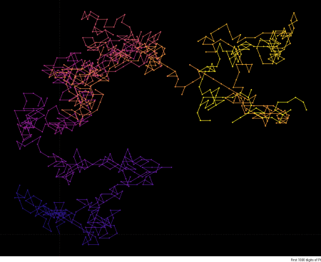

#ggsave(str_c("output/random_walk_pi_",n_steps,".png"), width=11, height=7)

n_steps <- 10000

## Random Walk of Pi

df_walk %>%

filter(pos < n_steps) %>%

ggplot(aes(x=cumsum_x, y=cumsum_y, color=pos)) +

geom_segment(size=0.1, aes(xend=cumsum_x_lag, yend=cumsum_y_lag)) +

geom_point(size=0.01) +

theme_void(base_family="Roboto Condensed") +

theme(panel.background=element_rect(fill="#000000")) +

scale_color_viridis_c(option="plasma", guide="none") +

labs(caption=paste("First",n_steps,"digits of Pi")) +

geom_hline(yintercept=0, color="#ffffff30", linetype=3) +

geom_vline(xintercept=0, color="#ffffff30", linetype=3)

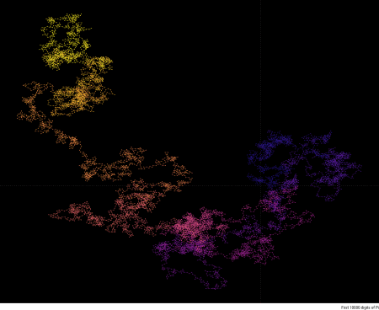

n_steps <- 100000

## Random Walk of Pi

df_walk %>%

filter(pos < n_steps) %>%

ggplot(aes(x=cumsum_x, y=cumsum_y, color=pos)) +

geom_segment(size=0.1, aes(xend=cumsum_x_lag, yend=cumsum_y_lag)) +

geom_point(size=0.005) +

theme_void(base_family="Roboto Condensed") +

theme(panel.background=element_rect(fill="#000000")) +

scale_color_viridis_c(option="plasma", guide="none") +

labs(caption=paste("First 100000 digits of Pi")) +

geom_hline(yintercept=0, color="#ffffff30", linetype=3) +

geom_vline(xintercept=0, color="#ffffff30", linetype=3)

